**INSTALL IBM CLOUD CLI**

|  |  |
| --- | --- |
| Date | 30 OCT 2022 |
| Team ID | PNT2022TMID45009 |
| Project Name | CUSTOMER CARE REGISTRY |

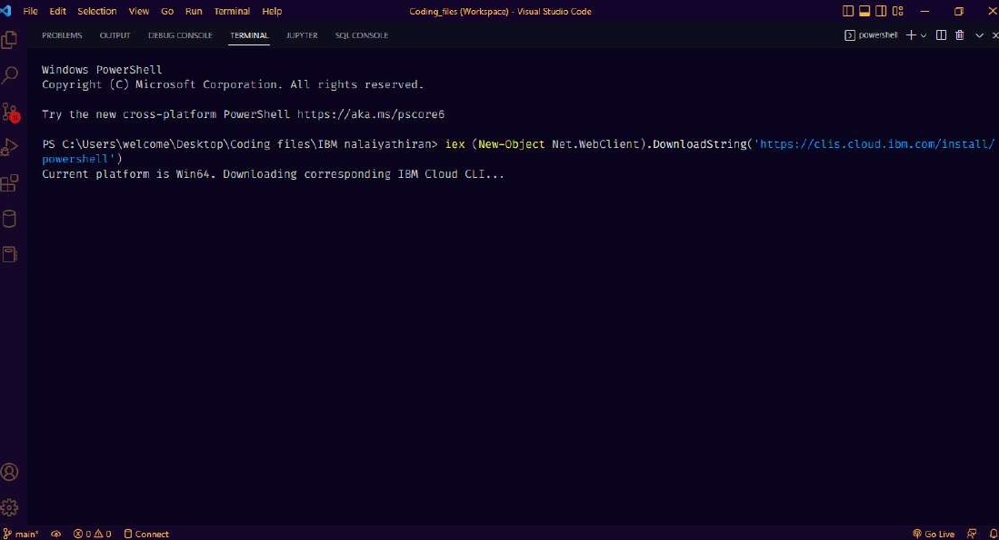IBM CLOUD CLI INSTALL

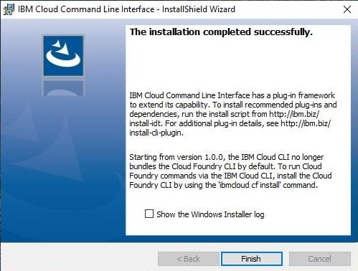  
IBM CLOUD INSTALL